**ASF COACHES AWARDS 2022**

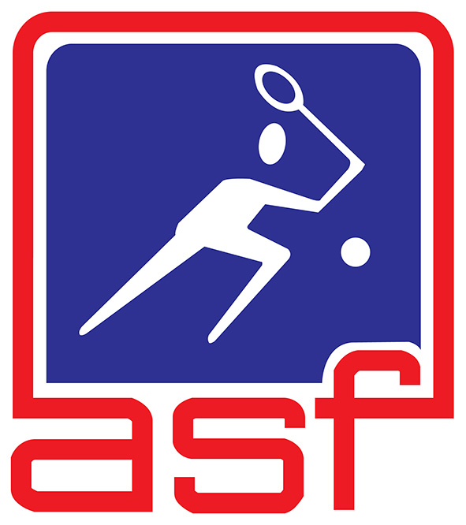

|  |
| --- |
| **NOMINATION FORM** |

**Procedure for filling the nomination form"**

1. The nomination form should be filled in a clear and concise manner.
2. Use an annex if the space provided is insufficient.
3. These awards are open to currently active coaches.
4. Only nomination forms duly completed and endorsed by the ASF member nation will be considered.
5. Submit **ONE colour passport size photo of nominee** along with nomination form.
6. Closing date for nominations: **17 February 2023**.
7. Late nominations or nomination with insufficient information will **NOT** be considered.
8. Completed nomination forms should be sent to:

**ASF SECRETARIAT**

**c/o Hong Kong Squash,**

**Hong Kong Squash Centre, 23 Cotton Tree Drive, Hong Kong**

**Tel : +852 28690330 Fax: +852 28690118**

**E-mail: info@asiansquash.org**

|  |  |
| --- | --- |
| **AWARDS CATEGORIES** | |
| (Please tick one of the following) | |
| **1. ASF Coach of the Year** |  |
| **2. ASF Junior Coach of the Year** |  |
| **3. ASF Development Coach of the Year** |  |
| **4. ASF Coaches Certificate of Recognition** |  |

*Page to be continued*

|  |  |  |  |  |  |
| --- | --- | --- | --- | --- | --- |
| **NOMINEE'S PERSONAL DATA** | | | | | |
| Name of nominee: | | (Surname) | | | (Given name) |
| Date of Birth: | | | | | Passport no.: |
| Address: | | | | | |
| Contact no.: | | | | | Email: |
| Highest Coaching Qualification Achieved (Level 1, 2, 3): in Year | | | | | |
| Coaching Experience (Club, State, National): | | | | | |
| **MAJOR COACHING ACHIEVEMENTS IN 2022** | | | | | |
| Name of competition: | | | | | |
| Names of athletes: | | | | | |
| Position attained: | | | | | |
| Additional supplementary information (if any): | | | | | |
| **NOMINATED BY** | | | | | |
| National Sports Association: | | |  | | |
| Name: | (Surname) | | | (Given name) | |
| Appointment: | | | | | |
| Contact no.: | | | | E-mail: | |
| Signature: | | | | Association's seal: | |
| Date: | | | |

- END -